CROCHET KNOCKERS
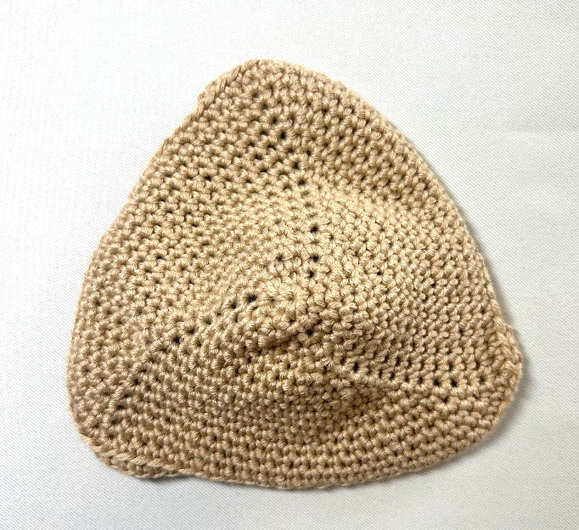 | 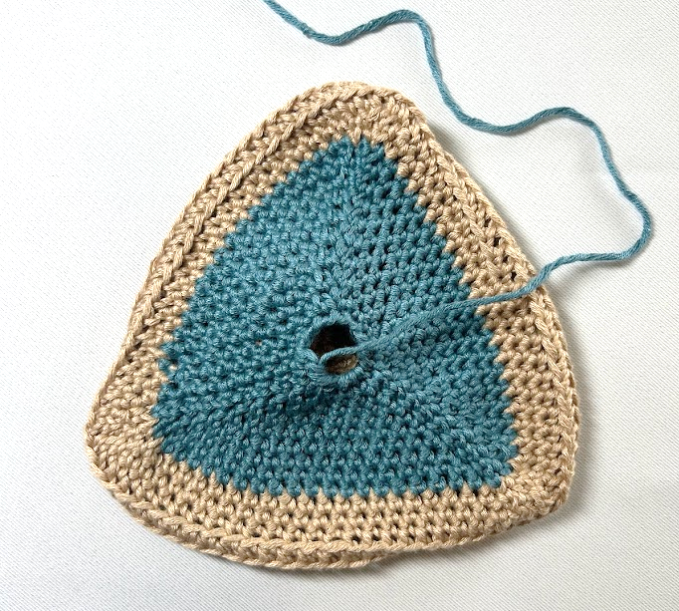

Size: A (B, C, D, DD)
Materials:
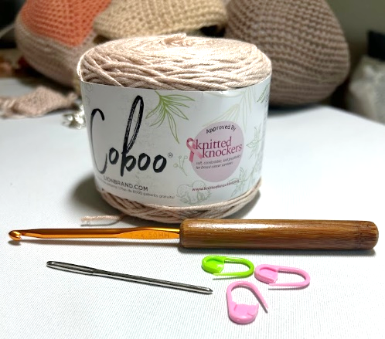
- 1 (1, 1, 2, 2) skeins of yarn from the Knitted Knocker approved yarn list. The yarn choice is very important.
- Size G (4.5mm) crochet hook (or size needed to get gauge)
- 3 locking stitch markers (1 in a different color for start of round)
- Tapestry needle
Gauge: 4 ½ sc and 5 ½ rows = 1-inch
Abbreviations:
ch = chain
pm = place marker rnd = round
sc = single crochet rep = Repeat
inc = work 2 scs in next sc
inv dec= invisible decrease (like sc2tog, but only in the front loops) Invisible Decrease Tutorial
Notes:
- Knockers are crocheted in a continuous spiral.
- To form a magic ring, take approximately 6” of yarn wrapped around your index finger twice, form a slip knot by pulling the yarn through the “ring”, then work 6 sc over both strands (through the ring). When complete, pull up tail to close ring. See magic ring video tutorial.

FRONT
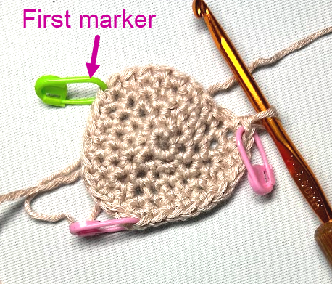
- Rnd 1: Create a magic ring with 6 sc in the ring. Close the ring.
- Rnd 2: inc x 6 (12 sc)
- Rnd 3: (2 sc, 2 inc, PM X 3 (18 sc) Video on marker placement tips- 10:40 (Link to tutorial on original crochet pattern)
- Rnd 4: (4 sc, 2 inc) x 3 (24 sc).Move Markers up as you go. Video link to moving markers up tips 15:55-17:46 (Link to original pattern tutorial)
- Rnd 5: (7 sc, inc) x 3 (27 sc)
- Rnd 6: (Work to 1 sc before marker and inc x 2) x 3 (33 sc)
- Rnd 7: (Work to marker and inc in marked stitch) x 3 (36 sc)
- Using the tapestry needle, sew in the magic ring’s 6” tail. At this point, you’ll start to see a spiral on the front of the Knocker. Video tip on weaving in tail Magic Ring Tutorial 3:48 (Link to original pattern tutorial)
- Select the cup size and continue.
Note: Tension and yarn choice may vary your stitch count to get proper sizing. So, use stitch count as a guide, but understand that sizing can be a bit of an art. You will size the Knockers after they’ve been stuffed.

- A cup – Repeat Rnds 6 & 7 three times until 4.5” across or 13 rounds (approx. 63 sc)
- B cup – Repeat Rnds 6 & 7 four times until 5” across or 15 rounds (approx.72 sc)
- C cup – Repeat Rnds 6 & 7 five times until 5.5” across or 17 rounds (approx. 81 sc)
- D cup – Repeat Rnds 6 & 7 six times until 6” across or 19 rounds (approx 90 sc)
- DD cup – Repeat Rnds 6 & 7 seven times until 6.5” across or 21 rounds (approx. 99 sc)
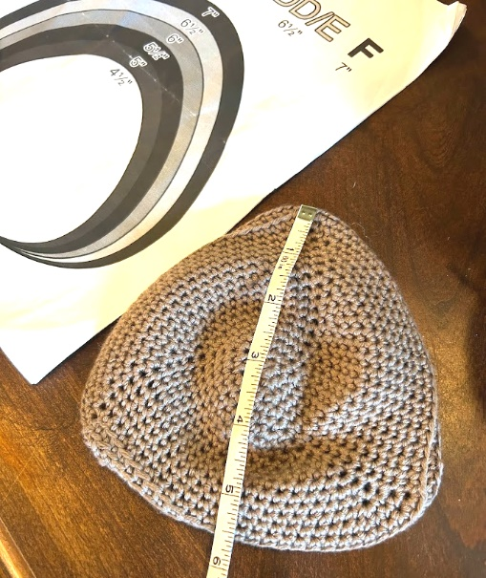
- For sizes larger than DD cup, keep adding rounds until the correct measurement for sizes larger than a DD cup. Each size is approximately 2 rnds or ½” across.

Note: This is a great time to take a look at the Size Chart. To get a size estimate, face the front of the Knocker toward you over the size chart. Measure from the tip of the triangle to the middle of the opposite site. You won’t be able to truly tell the size until it’s stuffed (it’s a bit of trial and error at first). Comparing the front of your Knocker to the chart should give you a good idea of how it will size when stuffed. Also, to get the proper measurement for the cup size, you may not finish exactly on the end of a row. You might end up in the middle!

TURNING ROWS

Work 2 rnds even through the back loop only.

BACK

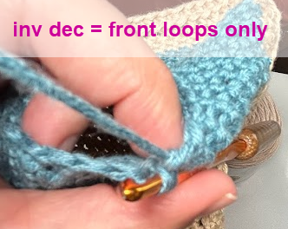
- When the size is correct, the turning rows have been completed, and you’re ready to start decreasing, crochet until 1 sc before the first marker.
Note: The back of the Knocker will lay flatter than the front. The decreases on the back of the Knocker should create straight lines toward the center as opposed to the swirl on the front.

Note: If changing color- start on third decrease row.

- Rnd 1: (inv dec (PM), inv dec, then sc until 1 sc before the next marker) x 3.
Keep the tension semi-tight on the invisible decreases to avoid gaps. But not so tight that you can’t get the hook through on the next round.

What's happening here? Your inv dec starts one stitch before the marker. Once both stitches are combined into one (a decrease), you place the marker on that first decreased stitch, then do one more inv dec. The marker goes in-between the two stitches to keep the "line" at the center of the triangular shape.

- Repeat Rnd 1 until you have 15 sc left.
- Cut yarn leaving a 10” tail.

- Important! Do Not Miss This Step! Thread tapestry needle and weave through the front loop only for the remaining 15 sc.

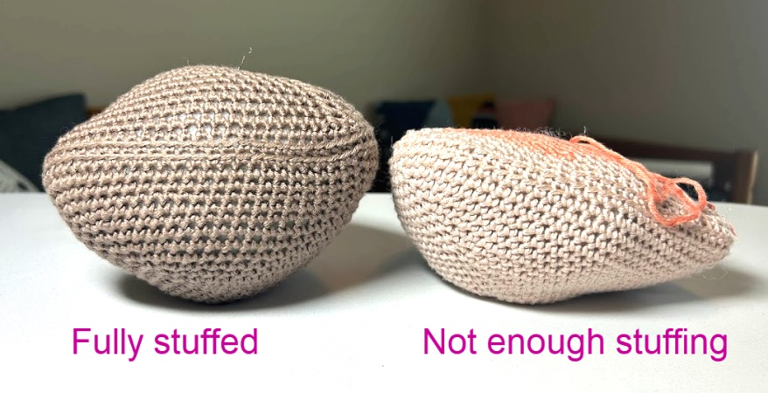
- If stuffing the Knocker:
  - Slightly overstuff with Poly-fil (or other fiber fill) Do not close hole as it is difficult to reopen. Stuffing will not come out when worn or washed.
  - Tuck tail into Knocker so that filling can be adjusted as needed.

- If mailing in unstuffed:
Leave the hole open and the yarn tail outside of the Knocker. If your yarn tends to fray easily, tie a loose knot at the end of the tail.

Other Helpful Notes

Approved Yarns Withstand Daily Use
See list of approved yarns
Knitted Knockers Support Foundation has created a list of tested and approved yarns appropriate for knitted Knockers. Please note that only Knockers made from this list will be used to fill orders from knittedKnockers.org.

Yarns appropriate for crochet Knockers have been identified on the list with a “C”.

Sizing
Sizing can be an art. Looser crochet will stretch more when stuffed. Stuffed Knockers should measure the diameters listed above measured straight across the back from the point to the mid of the opposite side.

Don’t stress too much about the sizing. The most important thing is to make sure that all pairs are the same size (same number of stitches). About 75% of the requests are for sizes B and C with the rest size A, D and DD. How to size a stuffed Knocker.

Only Light Neutral Colors on the front please
Light neutral colors are the top request.

- We define light neutral as the entire front of the Knocker shades of white, cream, beige, or sand.
- Dark neutral colors are defined as shades of brown or black.
- Pastel/Bright is defined as any color outside of those listed above. Knockers made with colored nipples will be given out in this category even if main color is neutral..

Most of our requests are for pairs of light neutral colors. Unless you are working up a specially requested Knocker, we ask that you work all Knockers in a light or dark neutral color for the entire front and the first three rows on the back. This is so the color doesn’t show when worn. Feel free to use any other color after the first three back rows.

Video Tutorials
We have posted a video on how to make great crochet Knockers at www.knittedKnockers.org. Grab a cup of coffee and enjoy watching Bunny (expert crocheter) teach Barb (novice crocheter) how to make great crochet Knockers. Bunny only has to rap Barb’s knuckles a couple of times! If you see differences in the video, go by the pattern as it may have been revised after the video was done. For a more instructional video you may enjoy our youth video where Aditi taught 20 classmates how to crochet beautiful Knockers.

Mailing Knockers for Distribution
If you don't have someone to give your beautiful Knocker to, please send them to us for distribution (always free to the recipient). We need lots of them! We request that you mail in pairs of matching Knockers because most requests are for two Knockers. Please no pins or baggies but rather a strand of yarn to tie pairs together. Include the name of the yarn used.

Send finished Knitted Knockers to:

1405 Fraser St. #F103
Bellingham, WA 98229

Be sure to include your contact information so that we can thank you!

List Yourself on Our Website
Visit www.knittedKnockers.org to learn more and to link yourself as a provider, or to locate a group in your area.

Thank you!!

Frequently Asked Questions

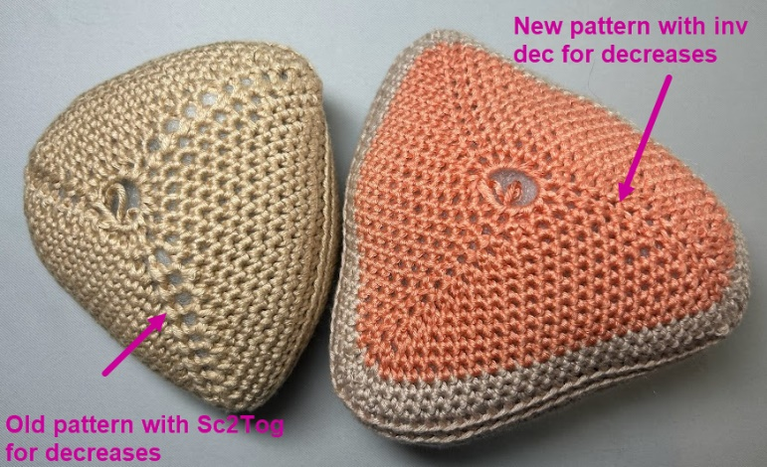
- Why did Knitted Knockers update the crochet pattern?
The main reason for this update is to swap out the Sc2Tog (single crochet two together) for an invisible decrease. We find that it closes up gaps, lays flatter, and provides a smoother back to the Knocker. See the photo for comparison.

- Can I still send in crochet Knockers made from the old pattern?
You can. We prefer you use this newer pattern. See the answer above. But we won’t turn down Knockers made from the old pattern so long as you use approved yarn.

- How can I do an inv dec (invisible decrease)?
It’s a lot like Sc2Tog, except that you only crochet the front loops together. See how to do the inv dec here.

- How much stuffing do I need to add to a Knocker?
If you are distributing the Knockers, stuff it full. You never know how much volume someone needs as some women are more concave than others, so we err on the side of caution and provide plenty!

- How do I measure the size of the Knocker?
See our sizing chart and video instructions on sizing.

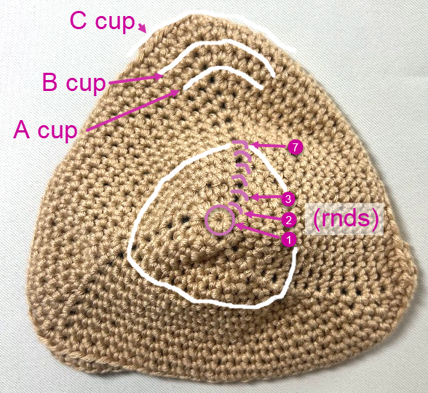
- Magic ring? I’m lost.
Check out this video.

- I lost count of my stitches. Help! Should I take the Knocker apart?
You might have to take it apart, and that’s totally OK. It happens even to the most experienced Knocker makers! However, before you do, see the visual to the right to help you identify where you’ve made increases. You can try counting back from there.

- Which row am I on?
Starting from the center and up toward your first different colored marker, you can follow along the rows to count. If it helps, try a row counter.

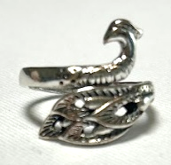
- My fingers hurt from holding the yarn tension. What can I do?
There are many techniques to hold your yarn at the right tension for you. It’s a very individualized thing. So, look around on YouTube and find the technique that works best for you. Another option a lot of Knocker makers use is a yarn ring, like this one:

- Do you take monetary donations?
We sure do! Mailing out pairs of Knockers to breast cancer survivors who are relieved to find a soft, light, washable alternative to the non-breathable, and heavy traditional prosthetics is our mission. But mailing is pricy! And the poly-fil stuffing adds up as well. We appreciate any monetary donation you can send.

You can make donations on our website: https://www.knittedKnockers.org/donations/ or by mailing us a check (1405 Fraser St. #F103, Bellingham, WA 98229).

- Crochet isn’t for me. Where’s the knitting pattern?
Find our other patterns and video tutorials here: https://www.knittedKnockers.org/make-a-Knocker/

Still have Questions?

Check out the FAQ section at knittedknockers.org.

