[www.knittedknockers.org](http://www.knittedknockers.org)



*soft, comfortable, knit prosthetics for breast cancer survivors*

[contact@knittedknockers.org](mailto:contact@knittedknockers.org)

Knitted Knockers 1405 Fraser St. #F103

Bellingham, WA 98229

**BOTTOMS UP KNOCKER**

**FOR DOUBLE POINT NEEDLES**

**(EASIER START FOR KNITTED KNOCKERS SAME GREAT RESULT!)** by Claudia Barbo, revised by L Furnas (4/17) rev 4/11/23

***Legend***

**CO** - Cast On

**kfb** - Knit into front & back of stitch

**M1R, M1L-** Make 1 Right, Make 1 Left

**K** - knit

**P** - purl

**k2tog** - knit 2 stitches together

**k2tog** **tbl**-knit 2 together through back loop

**Materials:** 1 set 7-8” double point needles, size US 4(5). Sport or (DK) weight soft, washable non wool yarn.**** See below for approved yarns for distribution by knittedknockers.org groups, stitch marker to mark needle 1, tapestry needle. Gauge- 6st= 1” (5st= 1”). Counts in ( ) are for DK/US 5 needles **BOTTOM PIECE:**

Starting with a 20” tail, CO loosely 15 sts and divide between 3 needles (5 per needle).

Round 1 – K to last st, kfb*** or M1R . Repeat for needle 2 & 3- 3 sts increased. Round 2 – Kfb*** or M1L, k to last st, kfb*** or M1R. Repeat for needle 2 & 3 - 6 sts increased.

Repeat rounds 1 & 2 until reach number of stitches for the cup size you desire.*

* A cup – stuffed diameter equals 4.5” (across) 72(66*) – 24(22*)/needle
* B cup – stuffed diameter equals 5” (across) 78(72) – 26(24)/needle
* C cup – stuffed diameter equals 5.5” (across) 90(78*) –30(26*)/needle
* D cup – stuffed diameter equals 6” (across) 102*(90) –34*(30)/needle
* DD/E cup – stuffed diameter equals 6.5” (across) 108(96) – 36(32)/needle

*(Certain sizes need to repeat Round 1- 1 more time to reach desired number of stitches).

**See notes for larger sizes. Each size goes up about ½” in diameter. Sizing is a bit of an art. Looser knit will stretch more when stuffed. Stuffed knockers should measure the diameters listed above measured straight across the back from the point to the mid of the opposite side.

**Turning Rows**: P 2 rounds. These two rounds help define the edge between the back and the front of your knocker.

**TOP PIECE** (W/OUT NIPPLE):

Decrease round: K to last 2 sts on each needle, k2tog*** or k2tog tbl. Repeat this round until you have 6 sts left (2 on each needle). Cut yarn leaving an 8” tail. Thread tail through remaining sts with tapestry needle and pull tight. Bring to inside of knocker and fasten off.

**TOP PIECE** (WITH NIPPLE):

Decrease round: K to last 2 sts on each needle, k2tog*** or k2tog tbl. Repeat this round until you have 3 sts left (1 on each needle). Knit these 3 sts on to one needle and proceed with an I-cord for 3 rounds. Cut yarn leaving an 8” tail. Using a tapestry needle thread tail through remaining sts. Stretch and twist I-cord tightly and stitch down all around it to create a small nipple. The completed nipple should be no more than 3/8” across.

**Final Step To Finish Bottom Piece:** Using tapestry needle, weave cast on tail through every other cast-on stitch. This will make a draw-string like closure so the knocker stuffing level can later be adjusted by the wearer.

Fill with Premium Poly Fiber Fil™ (optional, we can fill them for you to save on postage.) Do NOT cinch up!

**Visit** <http://www.knittedknockers.org/make-a-knocker/>for tips and videos on how to make the Bottoms Up Knitted Knockers for Double Point Needles. If you see differences in the video go by the pattern as it may have been revised after the video was done.

**Continued on Next Page**

**For larger sizes:

* F (7”) – repeat rounds 1 & 2 – 1 more time.
  + Complete turning rows
  + After the turning rows knit 2 rounds before starting top piece
* G (7.5”)-repeat rounds 1 & 2 – 2 more times.
  + Complete turning rows
  + After the turning rows knit 4 rounds before starting top piece.
* H (8”) & Beyond- Repeat rounds 1 & 2 an additional time per size
  + Complete turning rows
  + After the turning rows knit 4 rows before starting top piece

*** To avoid “laddering” or for a smoother finish the following stitches may be substituted for kfb- (M1R, M1L) or

K2tog- (K2tog tbl) (K 2 tog through the back loops). The alternate result gives no holes or laddering.

****Knitted Knockers Support Foundation has created a list of tested and approved yarns appropriate for knitted knockers. Please note that **only knockers made from this list will be used to fill orders from knittedknockers.org so if knitting or crocheting for us please only use these yarns**. While Knitted Knockers are a great “stash buster” taking only about 50 yards of yarn, the knockers may be worn against sensitive skin and must be durable, breathable and stay soft after washing. Also note the acrylic yarns are **only** used for swimming knockers. Here is a link to the approved yarn list [Approved Yarns](https://www.knittedknockers.org/wp-content/uploads/dlm_uploads/2016/10/Knitted-Knockers-Approved-Yarns-1page-12-29-22-rev1.pdf).

The most requests are for pairs of neutral colors. Neutral is defined as white, cream, beige, and sand. If you don’t have enough of one color to finish a knocker feel free to make the bottom piece with a bright or fun color using the same type of yarn changing to a neutral color 2-3 rows prior to the purl rows so the color doesn’t “peak” out when worn. Dark colors are defined as shades of brown or black. Very few requests are for colored or bright knockers. Don’t stress too much about the sizing. The most important thing is that each knocker within the pair has the same number of stitches. About 75% of the requests are for sizes B and C with the rest size A, D and DD. Check out the video at [knittedknockers.org](http://www.knittedknockers.org/make-a-knocker/) on How to Size your Knockers for sizing tips. If you see differences in the video, go by the pattern as it may have been revised after the video was done.

We realize that knitting on double pointed needles is not the easiest, but they are beautifully contoured, made in one piece and hold up really well. It is an easy, fun, and portable project, taking most people between 3-4 hours to make one. There is a video designed specifically for the Bottoms Up Knocker at knittedknockers.org. Watch Laureen, the Knocker Quality Queen teach Barb how to make knockers from the bottom up. If you see differences in the video go by the pattern as it may have been revised after the video was done.

If you don’t have someone to give your beautiful knocker to, please send them to us for distribution (always free to

the recipient). We need lots of them! Send with the yarn label to Knitted Knockers, 1405 Fraser St #F103, Bellingham,

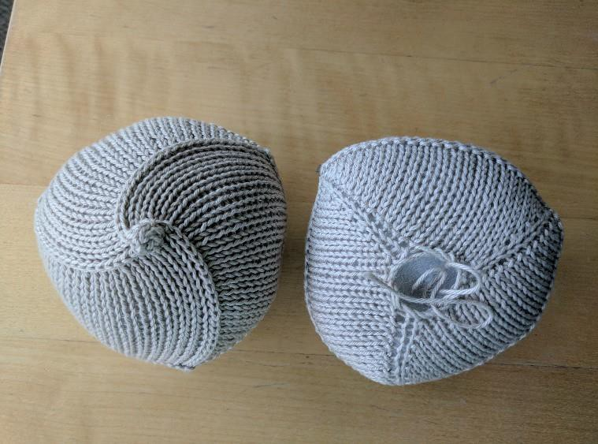WA, 98229. Be sure and include your contact info so we can thank you! Visit <http://www.knittedknockers.org/>(the one with the pink ribbon logo on it) to learn more and to link yourself as a provider, or to locate a group in your area. We have print materials we can help support you with including care instructions, cards and brochures. Thank you so much!!!